课题：Tim the turtle |  | 授课时间： | 撰写人：孙燕华
教材解读 | 本课选自派乐英语分级阅读书系，该书系属国家级课题“少儿英语分级阅读标准、资源和评价的研究与应用”实验教材。该书系难度梯度科学，含有童话、小说、综合等多个主题及故事性和纪实性题材，能够满足学生对阅读的多元需求。教学对象为小学三年级学生，以学生学习完三年级下册第三单元At the Zoo之后，以本绘本故事作为补充材料教学。本课以一只小乌龟找妈妈的故事，让学生在有趣而简单的故事当中学习更多的有关动物的单词，句型和对话。在课堂上中培养学生的语言运用能力，让学生在交际和表演中感受生活，体会语言的运用价值。
学习目标 | 1、知识目标：理解故事大意并描述动物花纹的不同，掌握句子“Are you my mum?”  2、能力目标：学习并掌握基本的阅读技巧；学会给新单词做标识和制作他们的单词小词典。掌握自行阅读的步骤和方法。  3、情感态度目标：学生感受到亲情的关怀，同时培养他们爱护动物的意识。
预习作业 | 1.准备一张和妈妈的合照
教学过程 |  |  |  | 学生学习个体清单
Step 1 Leading in-Free talk:
T asks some questions about the story:
T points to the cover of the book: What’s the story about? Is it about the tortoise or the cheetah? What’s the tortoise’s name? How can you know?

Step 2 Presentation
Pre-reading
T: This is a story about the tortoise and its name is Tim. But do you know what happens to him? T shows the question on PPT and lets the pupils to choose the answer.
While-reading
.T: You are so great. Later, You will listen to the story again. In this time, I want you to count how many animals Tim meet in the story.
Now, please listen carefully. Let’s go!
T puts on the headwear of the cheetah, zebra, fish and the tortoise to act out the story. And leads the pupils to practice the sentence “Are you my mom?"
(Let students count how many animals Tim meets in the story)
T asks the pupils to answer the question: “How many animals does Tim meet?”
2. Learn the four animals.
T shows the pictures of the four animals and let the students to find out the words"cheetah" "zebra" "fish" "tortoise"in their books quickly and then stick the label on the animals' bodies.
3.Learn the patterns.
Different animals have different patterns. Teacher helps the pupils to review the words "spots" "stripes" "scales" "rings" firstly and then ask the pupils to finish the exercise A.
Post-reading
Group work
Five pupils as a group and practise the dialogue: Are you my mom? No, I am a cheetah. I have spots....
Then teacher asks some groups to act it out.

Step 3: Exercise
- Tim the tortoise looks for his mom and meets many baby animal friends. How are these animals like their moms? Match A with B.
A B
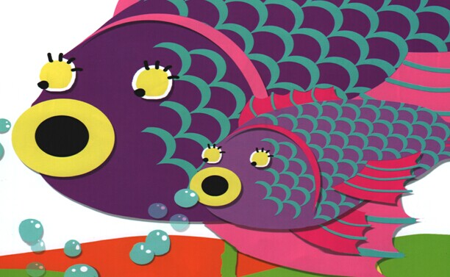
stripes
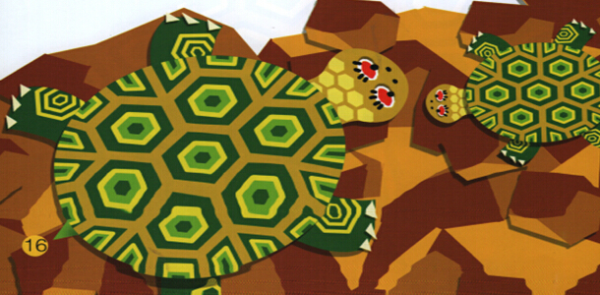
spots
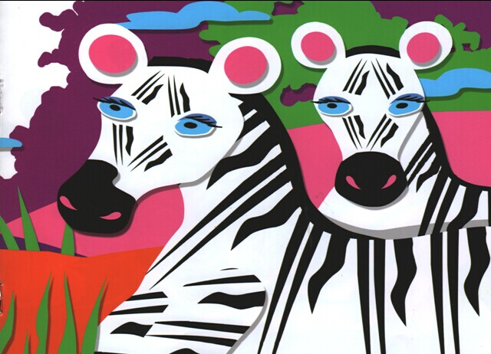
rings
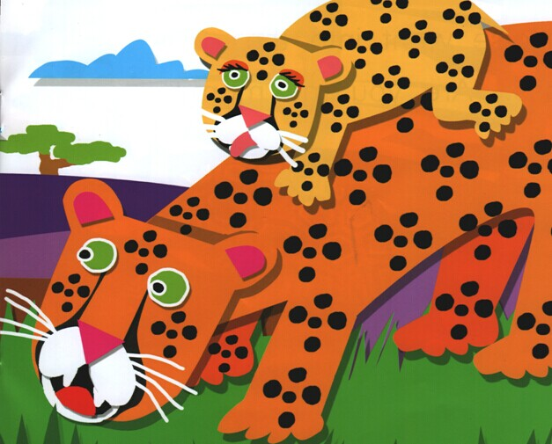
scales
B. Make my own dictionary.
cheetah |  | spots
 | 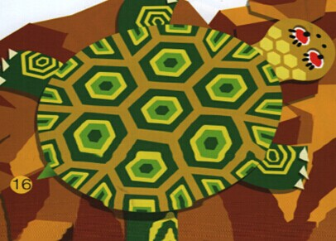

Step 4: Summary
T shows a video in which there are some photo of mother and her child.After watching, let the pupils to talk about how they are like their mother.
Step 5 Homework
Find your partners to play a role of the story or dub for the animals in the story.
Step 6 Blackboard Design

A: Are you my mom?
B: Yes./ No.
I am a ______________.
I have_______________.
Step7 Homework

Talk about your own mom.
作业设计：Talk about your mom.

课后反思：

